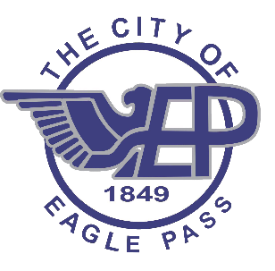
City of Eagle Pass Art and Culture Center
Release of Personal Property

I Jesus Omar Campos, hereby acknowledge the receipt of my personal property from the City of Eagle Pass Art and Culture Center, which was held for the purpose of holding an art exhibit. The personal property is described below:

- One Painting titled – La Chiva Muerta (on canvas)

The City of Eagle Pass Art and Culture Center is releasing this property on September 23, 2020.

________ I am accepting this property in good condition
________ I do not accept this property

______________________________ ____________
Print Name Date

_______________________________ ____________
Signature Date

